Injection and first applications
Introduction and Lab Report
Lab: SQL injection vulnerability in WHERE clause allowing retrieval of hidden data
Prepared by: Nihar Mane

INDEX
Part 1 - Introduction
1.1 SQL Injection…………………………………………………………………………………………2
1.2 SQL Parameters……………………………………………………………………………………..2

Part 2 - LAB SQL injection vulnerability in WHERE clause allowing retrieval of hidden data

2.1 Lab Metadata…………………………………………………………………………………….3
2.2 Summary…………………………………………………………………………………………3
2.3 Scope……………………………………………………………………………………………..3
2.4 Methodology……………………………………………………………………………………..3
2.5 Step-by-step procedure…………………………………………………………………………3
2.6 Impact Assessment……………………………………………………………………………..6
2.7 Remediation……………………………………………………………………………………...6
2.8 Conclusion……………………………………………………………………………………….6

References……………………………………………………………………………………………………6

PART 1 - INTRODUCTION

- SQL Injection: SQL injection is a security flaw in websites/apps that lets an attacker mess with the questions (queries) an application asks its database.
Because of this flaw, an attacker can:
- See data they shouldn't—like other users' private info or anything else the app has access to in its database.
- Change or delete data—sometimes they can even edit or wipe out information, which can permanently break or alter how the app works or what it shows.
- Eg: txtUserId = getRequestString("UserId");
- txtSQL = "SELECT * FROM Users WHERE UserId = " + txtUserId;

- Parameterized queries: SQL parameters can protect the website from attacks. It's a statement that uses placeholders instead of directly adding input values to the query text. Placeholders get replaced with the actual values when the query executes. This makes the queries safer and more reusable.
Most databases support parameterized queries, but the syntax varies:
- MySQL uses “?” for parameters
- SQL Server uses “@” for parameters
- PostgreSQL uses “$” for parameters

PART 2 - LAB

2.1 Lab Metadata

Lab name | SQL injection vulnerability in WHERE clause allowing retrieval of hidden data
Lab provider | PortSwigger Web Security Academy
Lab URL | https://portswigger.net/web-security/sql-injection/lab-retrieve-hi
Difficulty | Apprentice
Vulnerability class | SQL Injection — CWE-89
Target | Ephemeral PortSwigger lab instance (*.web-security-academy.net), /filter endpoint, category parameter
Tools used | Burp Suite Community Edition (Proxy/Intercept, HTTP History, Repeater), a Chromium-based lab browser
Date performed | August 27, 2026
Tester | Nihar Mane
Status | Solved

2.2 Executive Summary
This lab exploits a SQL injection flaw in the product category filter, where the category parameter is concatenated directly into a WHERE clause (SELECT * FROM products WHERE category = ‘<category>’ AND released = 1). Injecting ‘ OR 1=1-- via Burp Suite removed the released = 1 restriction, causing the application to disclose unreleased products to an unauthenticated user.

2.3 Scope
In scope: the category parameter of the /filter endpoint on the assigned PortSwigger lab instance. Out of scope: all other endpoints, parameters, and any production system.

2.4 Methodology

- Intercept the category request in Burp Suite Proxy.
- Modify the category parameter to inject SQL logic (‘+OR+1=1--).
- Forward the modified request, and the resulting intercepted response, to the server.
- Validate by checking the response for previously hidden, unreleased products

2.5 Step-by-step procedure

Step 1: We open the lab in the Burp Suite browser and at first make sure that intercept is “ON”.

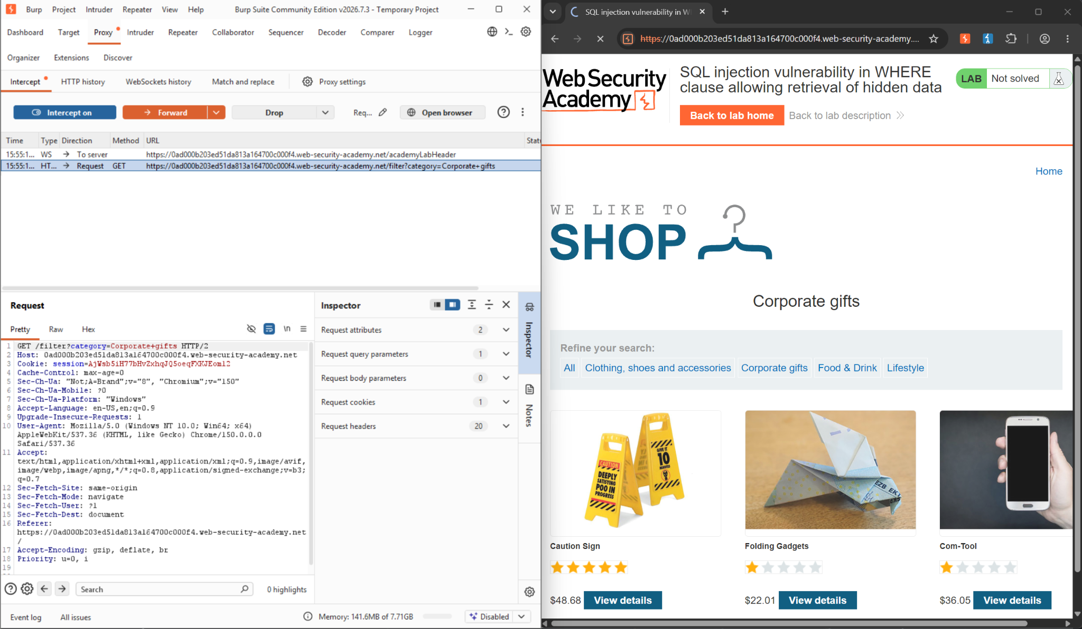

Step 2: Modify the category parameter, giving it the value '+OR+1=1–

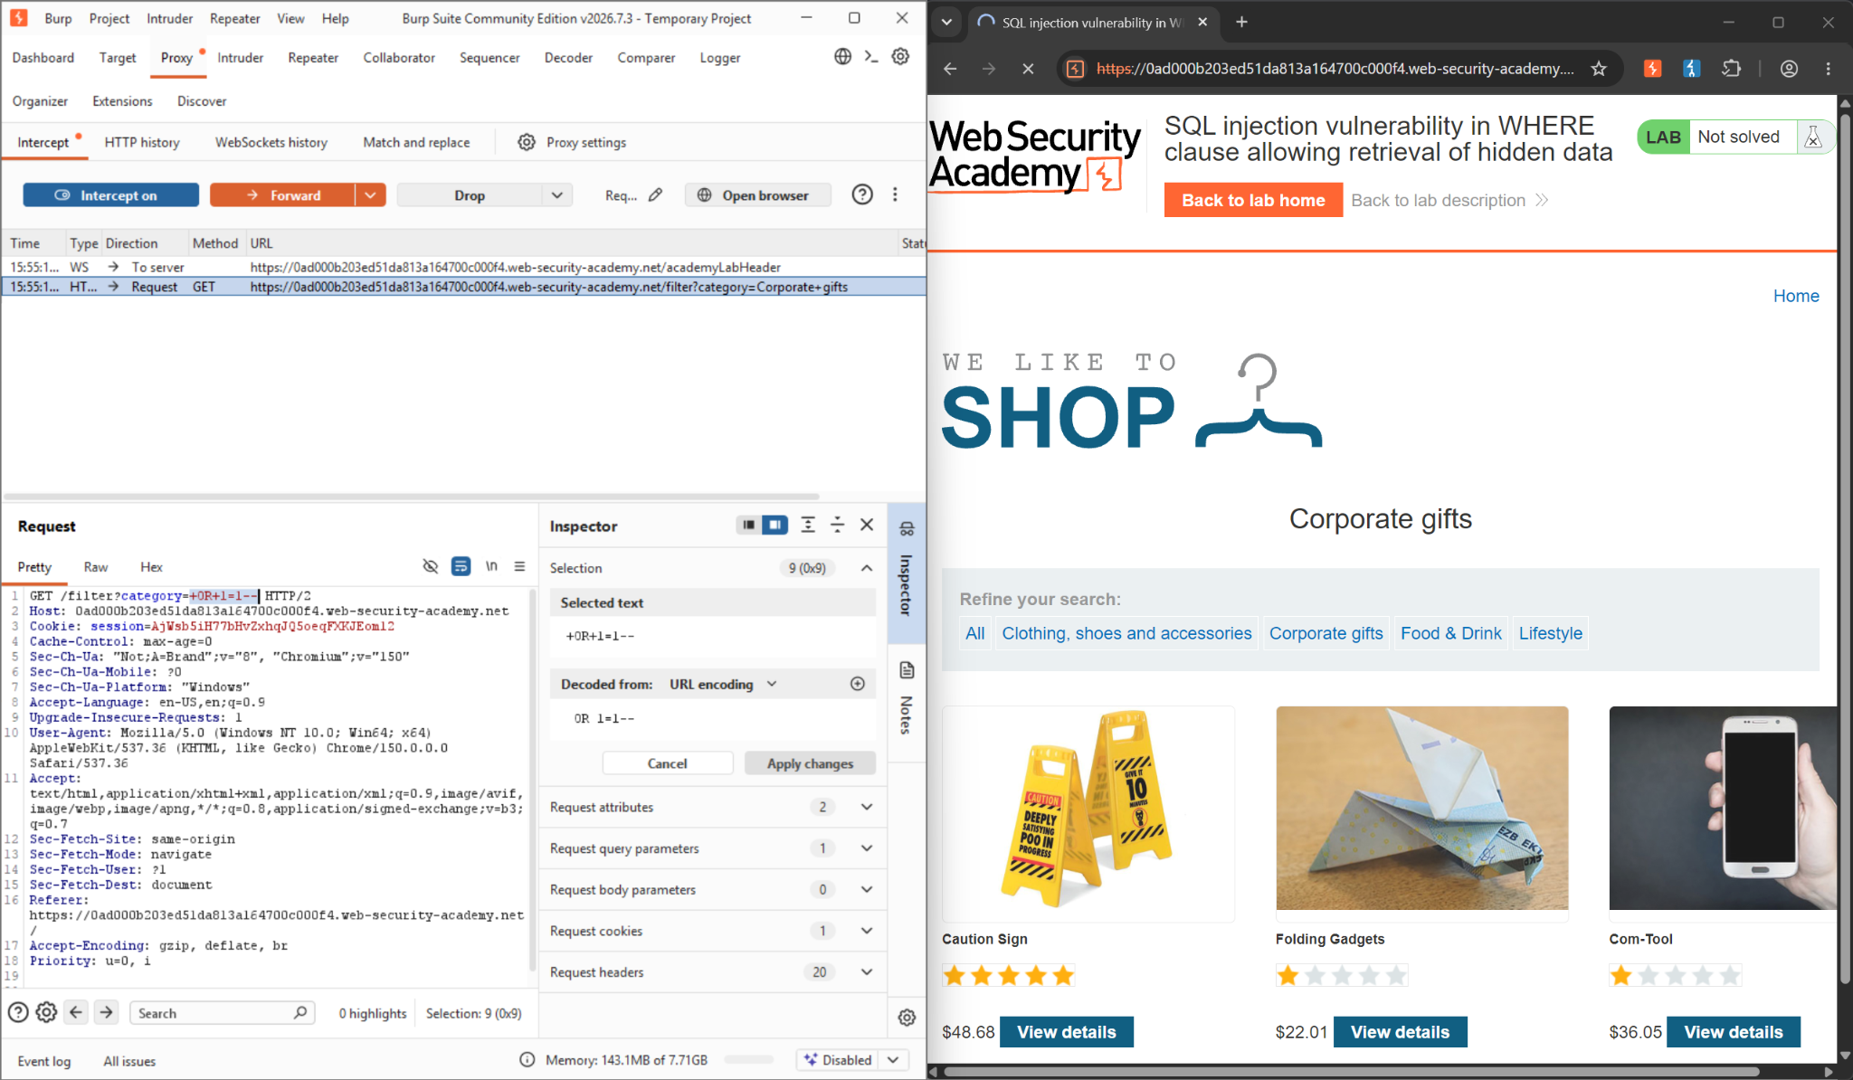

Step 3: After changing the category, go to settings and enable Response Intercept Rules
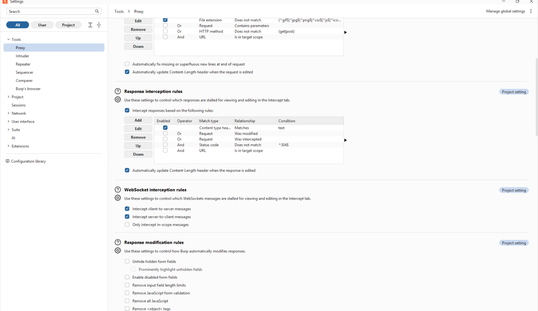

Step 4 : After forwarding the request, the server gave this response.

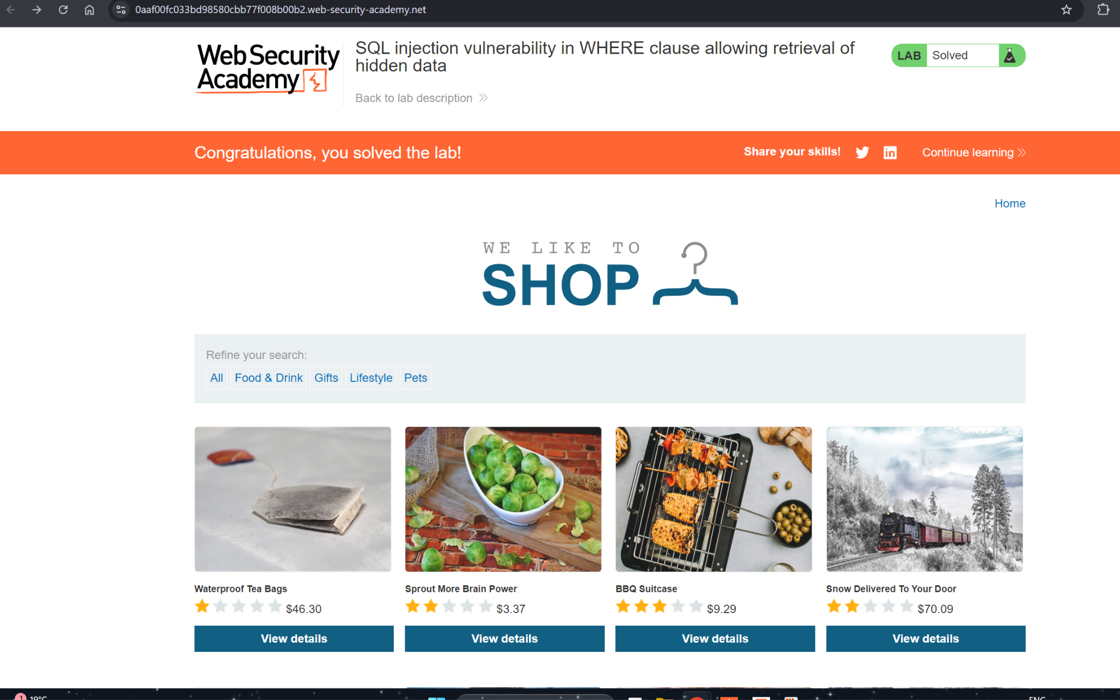

2.6 Impact Assessment

● Confidentiality: unreleased product data was disclosed to an unauthenticated user.
● Escalation potential: the same parameter could support a UNION-based attack to pull data from other tables.
● Low complexity: no authentication was required, and the exploit needed only one modified parameter.

2.7 Remediation

● Use parameterized queries / prepared statements for the category filter (see 1.2).
● Validate category against an allowlist of known-good values.
● Apply least-privilege database permissions and avoid verbose SQL error messages.

2.8 Conclusion

This lab confirmed the theory from Part 1 in practice: concatenating unsanitized input into an SQL WHERE clause lets an attacker rewrite the query’s logic and bypass the released = 1 restriction. A single ‘ OR 1=1-- payload, delivered and forwarded through Burp Suite, was enough to disclose hidden product data—reinforcing why parameterized queries are the correct fix.

References:

- SQL Injection - https://portswigger.net/web-security/sql-injection#what-is-sql-injection-sqli
- SQL Parameters - https://www.w3schools.com/SQl/sql_parameterized_queries.asp
- LAB - https://portswigger.net/web-security/sql-injection/lab-retrieve-hidden-data

